Programming Exercise 12:

K-means Clustering and Principal Component

Analysis

K-means Clustering

In this this exercise, you will implement the K-means algorithm and use it for image compression. You will first start on an example 2D dataset that will help you gain an intuition of how the K-means algorithm works. After that, you will use the K-means algorithm for image compression by reducing the number of colors that occur in an image to only those that are most common in that image.

1.1 Implementing K-means

The K-means algorithm is a method to automatically cluster similar data examples together. Concretely, you are given a training set {x(1); :::; x(m)} (where x(i) 2 Rn), and want to group the data into a few cohesive “clusters".

The intuition behind K-means is an iterative procedure that starts by guessing the initial centroids, and then refines this guess by repeatedly assigning examples to their closest centroids and then recomputing the centroids based on the assignments.

The K-means algorithm is as follows:

% Initialize centroids

centroids = kMeansInitCentroids(X, K);

for iter = 1:iterations

% Cluster assignment step: Assign each data point to the

% closest centroid. idx(i) corresponds to cˆ(i), the index

% of the centroid assigned to example i

idx = findClosestCentroids(X, centroids);

% Move centroid step: Compute means based on centroid

% assignments

centroids = computeMeans(X, idx, K);

end

The inner-loop of the algorithm repeatedly carries out two steps: (i) Assigning each training example x(i) to its closest centroid, and (ii) Recomputing the mean of each centroid using the points assigned to it. The K-means algorithm will always converge to some final set of means for the centroids.

Note that the converged solution may not always be ideal and depends on the initial setting of the centroids. Therefore, in practice the K-means algorithm is usually run a few times with different random initializations. One way to choose between these different solutions from different random initializations is to choose the one with the lowest cost function value (distortion).

You will implement the two phases of the K-means algorithm separately in the next sections.

1.1.1 Finding closest centroids

In the “cluster assignment" phase of the K-means algorithm, the algorithm assigns every training example x(i) to its closest centroid, given the current positions of centroids. Specifically, for every example i we set:



where c(i) is the index of the centroid that is closest to x(i), and µj is the position (value) of the j'th centroid. Note that c(i) corresponds to idx(i) in the starter code.

Your task is to write function takes the data matrix X and the locations of all centroids inside centroids and should output a one-dimensional array idx that holds the index (a value in {1; :::;K}, where K is total number of centroids) of the closest centroid to every training example.

You can implement this using a loop over every training example and every centroid.

Once you have completed the code you should see the output [1 3 2] corresponding to the centroid assignments for the first 3 examples.

1.1.2 Computing centroid means

Given assignments of every point to a centroid, the second phase of the algorithm recomputes, for each centroid, the mean of the points that were assigned to it. Specifically, for every centroid k we set



where µk is the set of examples that are assigned to centroid k. Concretely, if two examples say x(3) and x(5) are assigned to centroid k = 2, then you should update µ2 = 1/2(x(3) + x(5)).

You should now complete the code. You can implement this function using a loop over the centroids. You can also use a loop over the examples; but if you can use a vectorized implementation that does not use such a loop, your code may run faster.

Once you have completed, run your code and output the centroids after the first step of K-

means.

1.2 K-means on example dataset

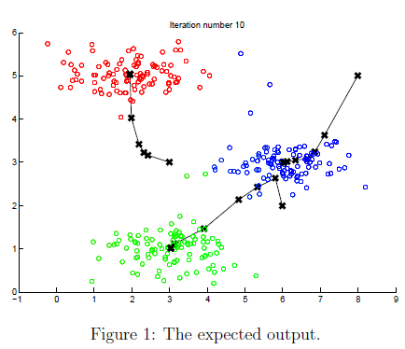

At the end, your figure should look as the one displayed in Figure 1.

1.3 Random initialization

The initial assignments of centroids for the example dataset were designed so that you will see the same figure as in Figure 1. In practice, a good strategy for initializing the centroids is to select random examples from the training set.

In this part of the exercise, you should complete the function kMeansInitCentroids with the following code:

% Initialize the centroids to be random examples

% Randomly reorder the indices of examples

randidx = randperm(size(X, 1));

% Take the first K examples as centroids

centroids = X(randidx(1:K), :);

The code above first randomly permutes the indices of the examples (using randperm). Then, it selects the first K examples based on the random permutation of the indices. This allows the examples to be selected at random without the risk of selecting the same example twice.

1.4 Image compression with K-means

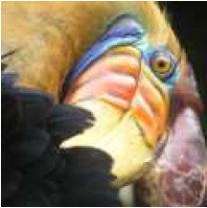

Figure 2: The original 128x128 image.

In this exercise, you will apply K-means to image compression. In a straightforward 24-bit color representation of an image,2 each pixel is represented as three 8-bit unsigned integers (ranging from 0 to 255) that specify the red, green and blue intensity values. This encoding is often refered to as the RGB encoding. Our image contains thousands of colors, and in this part of the exercise, you will reduce the number of colors to 16 colors.

By making this reduction, it is possible to represent (compress) the photo in an efficient way. Specifically, you only need to store the RGB values of the 16 selected colors, and for each pixel in the image you now need to only store the index of the color at that location (where only 4 bits are necessary to represent 16 possibilities).

In this exercise, you will use the K-means algorithm to select the 16 colors that will be used to represent the compressed image. Concretely, you will treat every pixel in the original image as a data example and use the K-means algorithm to find the 16 colors that best group (cluster) the pixels in the 3-dimensional RGB space. Once you have computed the cluster centroids on the image, you will then use the 16 colors to replace the pixels in the original image.

1.4.1 K-means on pixels

In Octave/MATLAB, images can be read in as follows:

% Load 128x128 color image (bird small.png)

A = imread('bird small.png');

% You will need to have installed the image package to used

% imread. If you do not have the image package installed, you

% should instead change the following line to

%

% load('bird small.mat'); % Loads the image into the variable A

This creates a three-dimensional matrix A whose first two indices identify a pixel position and whose last index represents red, green, or blue. For example, A(50, 33, 3) gives the blue intensity of the pixel at row 50 and column 33.

First loads the image, and then reshapes it to create an mX3 matrix of pixel colors (where m = 16384 = 128 X 128), and calls your K-means function on it.

After finding the top K = 16 colors to represent the image, you can now assign each pixel position to its closest centroid using the findClosestCentroids function. This allows you to represent the original image using the centroid assignments of each pixel. Notice that you have significantly reduced the number of bits that are required to describe the image. The original image required 24 bits for each one of the 128X128 pixel locations, resulting in totalsize of 128X128X24 = 393.216 bits. The new representation requires some overhead storage in form of a dictionary of 16 colors, each of which require 24 bits, but the image itself then only requires 4 bits per pixel location. The final number of bits used is therefore 16 X 24 + 128 X 128 X 4 = 65.920 bits, which corresponds to compressing the original image by about a factor of 6.

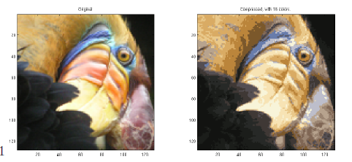

Figure 3: Original and reconstructed image (when using K-means to compress the image).

Finally, you can view the effects of the compression by reconstructing the image based only on the centroid assignments. Specifically, you can replace each pixel location with the mean of the centroid assigned to it. Figure 3 shows the reconstruction we obtained. Even though the resulting image retains most of the characteristics of the original, we also see some compression artifacts.

1.5 Use your own image

In this exercise, modify the code we have supplied to run on one of your own images. Note that if your image is very large, then K-means can take a long time to run. Therefore, we recommend that you resize your images to managable sizes before running the code. You can also try to vary K to see the effects on the compression.